DENVER RTD EAGLE P3
COMMUNICATION SYSTEM

FIELD MODIFICATION INSTRUCTIONS
FMI #18: LIC / VOIP

software updates.
CONTRACT NO. | P110701149
CDRL NO. | N/A
WIS DOC. NO. | 42B-2018-0018
REVISION: | 1.0
DESIGNED: | D. S. JANG
REVIEWED: | J. Y. LEE
APPROVED: | B. J. JONE
DATE: | 2/08/2018



Record of Revisions
Rev. | Date | Description | Entered By
1.0 | 2/08/2018 | Initial release | D. S. Jang

Table of Contents
1. Introduction 4
2. Summary 4
3. Instructions 4
3.1 Location of Equipment 4
3.2 Software Update DESCRIPTION 6
3.2.1 LIC Algorithm Block Diagram 6
3.2.2 VOIP Algorithm Block Diagram 8
3.3 TEST AND VERIFICATION 10
3.4 VERSION ChECK 10
4. Tracking 10

Introduction
This FMI provides instructions to install the Communication System update to the vehicles.

Summary
This FMI applies to following software configuration item:
- LIC SW change.
- VOIP SW change.

Instructions

Location of Equipment
Following figures show the location of equipment to be updated.
VOIP Board
LIC Board

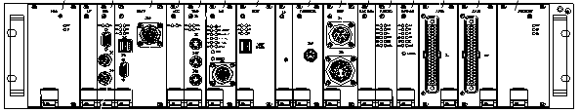
Figure 1 – CNCS Board Location
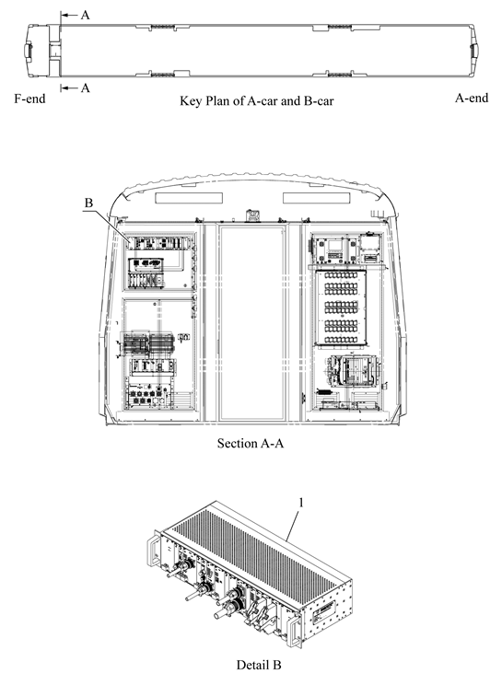
Figure 2 – CRA Location

Software Update DESCRIPTION

LIC Algorithm Block Diagram

#CAB Change Algorithm
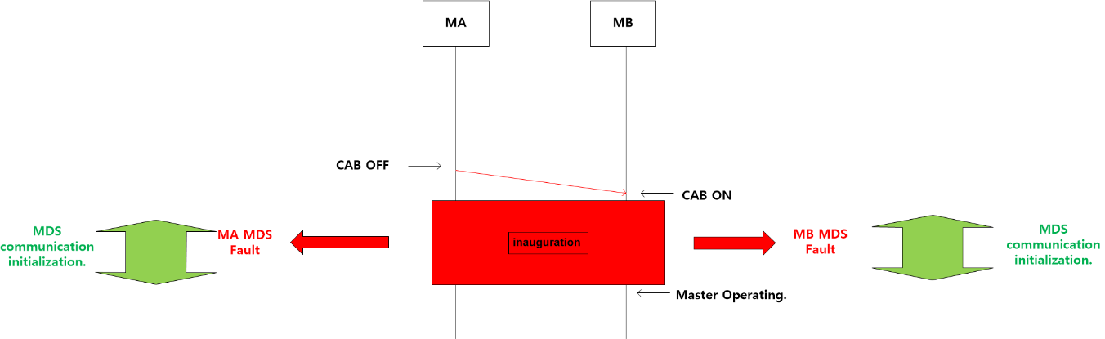
Figure 3 – CAB Change Algorithm

- Before Change
- CAB change is occurred at the last station during the train service.
- The CRA-PAMCU is operated "Inauguration" to check the multi-coupled train information of the vehicle.
- Pause the communication of sub device during "Inauguration".
- MDS fault is occurred due to the interruption of the sub-device communication.
- When complete 'Inauguration', the MDS fault is cleared.

- After Change.
- CAB change is occurred at the last station during the train service.
- CRA-PAMCU is operated "Inauguration" to check the multi-coupled train information of the vehicle.
- Pause the communication of sub device during "Inauguration".
- When the LIC Board detects "Inauguration" operation, it suspends the communication error counter until "Inauguration" is completed.
- When the "Inauguration" is completed, the communication error check will be started.

# Windows rebooting Algorithm
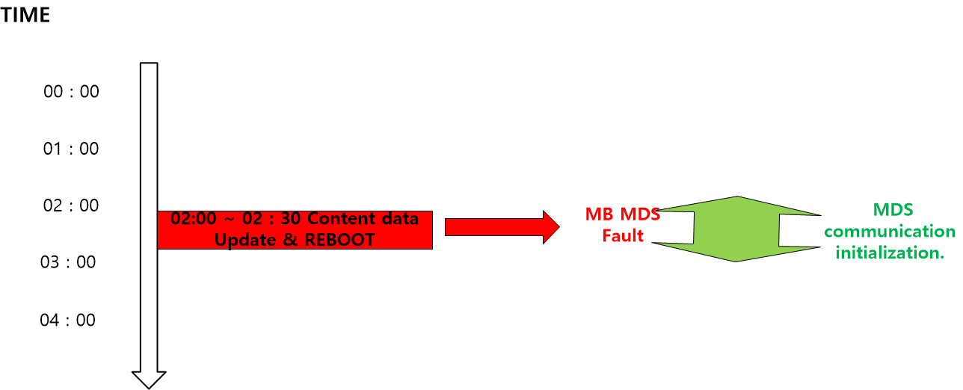
Figure 4 – Windows rebooting Algorithm
- Before Change.
- To optimize the embedded Window, CRA - CNCS performs AM 02:00 rebooting to delete temporary files occurred during the train service and to check the network status.
- During the rebooting, the main application generated on CRA-CNCS is occurred the communication error and MDS fault. fault occurs.
- After Change.
- To optimize the embedded Window, CRA - CNCS performs AM 02:00 rebooting to delete temporary files occurred during the train service and to check the network status.
- During rebooting, LIC Board will not check the communication counter until AM 02:00~02:30.

VOIP Algorithm Block Diagram
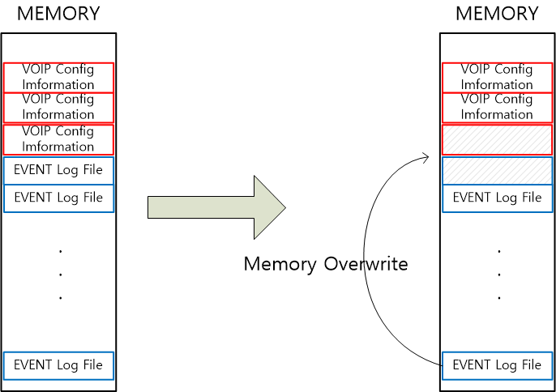
Figure 5 – VOIP Memory Overwrite Algorithm

- Before Change.
- CRA - VOIP PCB records call log when OCC call event is occurred.
- When the log file is full of memory, it performs an overwrite operation.
- During the overwrite, the memory block data is deleted which recorded the VOIP Config Information.
- When VOIP Linux booting, the abnormal operation is occurred due to the use of damaged VOIP Config Information.
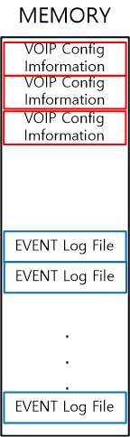
Figure 6 – VOIP Memory

- After Change.
- CRA - VOIP PCB records call log when OCC call event occurs.
- When the log file is full of memory, it performs an Overwrite operation.
- Separate the memory to prevent loss of VOIP config information.

TEST AND VERIFICATION
After updating the CCP software, follow the procedure below to verify the functionality:
- Key-on the cab
- Using the CCP touchscreen, enter route number 10 or 11
- Run the route simulation
- Verify the simulated announcements and displays function appropriately.

VERSION ChECK
Use the MDS Software Version menu to verify the updated software versions.
- CRA-LICM : 1.1.04
- CRA-VOIP : 1.1.04

Tracking
Status of the field modification activities will be tracked and managed for car number and items completed. The progress will be reported to DTP/H-Rotem in daily basis as the modification proceeds.

NUM | HW |  |  | SW |  | Remarks
 | DPO | PDI | CCP | CRA-LICM | CRA-VOIP
4001-2
( - - )
4003-4
( - - )
4005-6
( - - )
4007-8
( - - )
4009-10
( - - )
4011-12
( - - )
4013-14
( - - )
4015-16
( - - )
4017-18
( - - )
4019-20
( - - )
4021-22
( - - )
4023-24
( - - )
4025-26
( - - )
4027-28
( - - )
4029-30
( - - )
4031-32
( - - )
4033-34
( - - )
4035-36
( - - )
4037-38
( - - )
4039-40
( - - )
4041-42
( - - )
4043-44
( - - )
4045-46
( - - )
4047-48
( - - )
4049-50
( - - )
4051-52
( - - )
4053-54
( - - )
4055-56
( - - )
4057-58
( - - )
4059-60
( - - )
4061-62
( - - )
4063-64
( - - )
4065-66
( - - )

